**TA201A: MANUFACTURING PROCESSES**  Project Report | Group No: 5 (Tuesday) **Warrior Helmet**

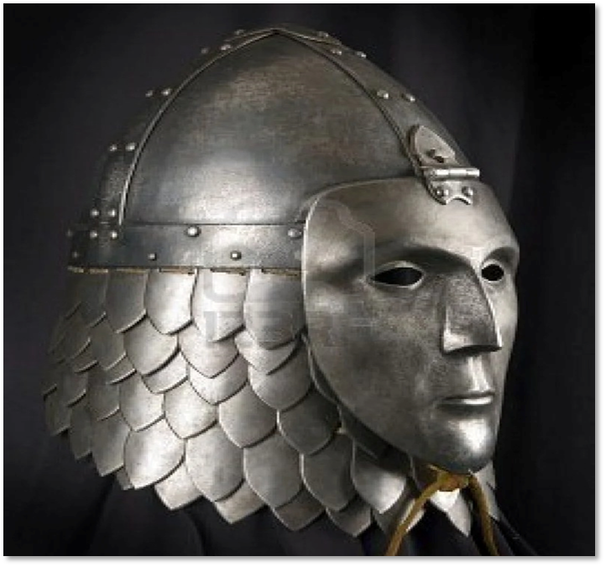

**Tutors: Dr. Srinu Gangolu**

**Lab-In-Charge: Mr. Anil Kumar Verma**

**Course-Staff-in-Charge: Mr. IP Singh**

**Course Instructor :Dr. Niraj Mohan Chawake**

**GROUP MEMBERS:**

**1.HARSHA ADITYA (210416)** **..................... . 5.INDRESH SINGH (210452) ..................... .**

**2.HARSHIT SAINI (210426)** **.................... . 6.JAHNVI SINGH (210460)** **..................... .**

**3.HAVI BOHRA (210429)** **..................... . 7.JAYANT SONI (210468) ..................... .**

**4.HIMANSHU PATIDAR (210444) ..................... .**  Index

|  |  |
| --- | --- |
| **Contents** | **Page No.** |
| Index | II |
| Introduction | III |
| Motivation | IV |
| Acknowledgement | V |
| Work Distribution | VI |
| Materials List | VII |
| Main Isometric | VIII |
| Part Drawings | IX |

***INTRODUCTION***

* **Helmets** are a defensive covering for the head, one of the most universal forms of armor. Helmets are usually thought of as military equipment, but they are also worn by firefighters, miners, construction workers, riot police and motorcyclists, players of several sports, and bicyclists. Military helmets date from ancient times. Their basic function was to protect the head, face, and sometimes the neck from projectiles and the cutting blows of swords, spears, arrows, and other weapons.
* Helmets are used as a head protection tool for a long time. Earlier it was used in wars and battles, today it is used by us for driving and many adventurous purposes. The ancient models are as armor usually considered objects beautiful, rather than useful. They are exhibited in museums, in halls hung with tapestries, beside faience, ivories, and enamels of olden times.

***MOTIVATION***

* Our group has been motivated to build this project using various modern techniques and materials. Under this project, we are trying to create an old historical model of armor helmets using modern techniques and art. We are excited to accomplish this project in a way that looks like a real thing and the guidance, support, and motivation from the respected instructors and team spirit are the main keys to making it happen.
* This project mainly involves some modern and traditional methods of metallurgical engineering including some sorts of sheet metal works, moulding & casting, welding, riveting, etc.

***ACKNOWLEDGEMENT***

We would like to express our profound gratitude to our tutor Dr Srinu Gangolu, MSE laboratory in charge Anil K. Verma and course staff in charge Mr Indra Pal Singh for their able guidance and support for our project titled “Warrior Helmet”.

We are also very grateful to Mr Nripen Deka, Mr Rakesh Kumar, Mr Gaurav Mishra, Mr Anurag Prasad, Mr B R Singh and Mr Pappu for their constant supervision and valuable suggestions throughout the completion of our project.

We would also like to extend special thanks to all TAs for their valuable time and suggestions.

Finally, I apologize to all the other unnamed who helped us in various ways to have a great project.

**Work distribution**

|  |  |  |  |  |  |  |
| --- | --- | --- | --- | --- | --- | --- |
| Members | Week 1 | Week 2 | Week 3 | Week 4 | Week 5 | Week 6 |
| Harsha | Cutting Petals | Top joint cutting | Metal cap and strips rivetting | Casting and Moulding Face | Final Assembly | Finishing work |
| Harshit | Cutting Petals | Top joint cutting | Metal cap and strips rivetting | Spot welding petals | Final Assembly | Finishing work |
| Havi | Cutting Strips & Rim | Metal cap making | Metal cap and strips rivetting | Casting and Moulding Face | Final Assembly | Final Testing |
| Himanshu | Cutting Petals | Metal cap making | Spot welding petals | Spot welding petals | Final Assembly | Final Testing |
| Indresh | Cutting Petals | Clip making | Spot welding petals | Spot welding petals | Final Assembly | Finishing work |
| Jahnvi | Cutting Petals | Clip making | Spot welding petals | Casting and Moulding Face | Final Assembly | Finishing work |
| Jayant | Cutting Strips & Rim | Clip making | Spot welding petals | Casting and Moulding Face | Final Assembly | Finishing work |

**Materials List**

|  |  |  |  |  |  |
| --- | --- | --- | --- | --- | --- |
| **Part**  **No.** | **Part Name** | **Dimensions** | **Quantity** | **Materials Required** | **Process Used** |
| 1. | Metal Cap | D200 x 0.5 | 1 | Mild Steel Sheet | Cutting, Sheet Metal |
| 2. | Metal Cap Joint | 60 x 60 x 0.5 | 1 | Mild Steel Sheet | Cutting, Sheet Metal, Drilling |
| 3. | Strips | 25 x 370 x 1 | 2 | Mild Steel Sheet | Cutting, Sheet Metal |
| 4. | Rim | 25 x 605 x 1 | 1 | Mild Steel Sheet | Cutting, Sheet Metal |
| 5. | Petals | 30 x 40 x 0.5 | Approx 80 | GI Sheet | Cutting, Sheet Metal |
| 6. | Face | 115 x 200 x 2 | 1 | Aluminium | Casting and Moulding |
| 7. | Clip | 40 x 40 x 0.5 + D3 mm | 1 | Mild Steel Sheet + 3mm MS rod | Cutting, Sheet Metal, Drilling, Brazing |